Parts Bin

**Cultivation Methods**

Current methods of rice cultivation include the flooding of paddy fields. Unlike other types of cultivated plants, rice is semi-aquatic in nature. It can survive prolonged periods of submergence and oxygen limiting. Behavioral analysis indicates that the rice plant mitigates the deprivation effects by elongation of the stem or by metabolic adaptations (Das & Uchimiya). The irrigation requirements of rice production has a different model when compared with other types of cultivated plants. Other form of rice cultivation is the process of rearing aquatic animals along with the rice plants. The rice-fish cultivation system is a type of a semi-intensive aquaculture technique where common hardy fishes like Cyprinus carpio (common carp) or Oreochromis niloticus (Nile Tilapia) are reared within paddies of rice. The reared fishes establish mutualism by providing nutrients to the plants through excreted waste and eating the pests that are local to the area. The other side of mutual relationship is that the rice plants act as biological filtration to the water thus making it suitable for the fishes to thrive (Lu & Li).

Based on the results of an earlier study for a single variety of rice (Yadav and

Jindal, 1998), it was hypothesized that the weight of individual kernels, whether of

head rice and broken fraction, is proportional to their respective dimensional

features.

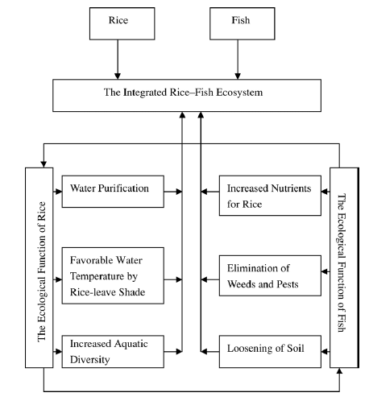

Figure. Rice-fish cultivation system diagram (Lu & Li)